Implementing R Hypothesis Testing
Cecil Kitch
Colorado State University – Global Campus
R Code
# R Hypothesis Tests
require("dplyr")
tScore_before <- c(40, 62, 74, 22, 64, 65, 49, 49, 49)
tScore_after <- c(68, 61, 64, 76, 90, 75, 66, 60, 63)

# Create a data frame
my_data <- data.frame(
group = rep(c("Score Before", "Score After"), each = 9),
scores = c(tScore_before, tScore_after)
)
# Print all data
print(my_data)

#Compute summary statistics by groups
group_by(my_data, group) %>%
summarise(
count = n(),
mean = mean(scores, na.rm = TRUE),
sd = sd(scores, na.rm = TRUE)
)

# Compute Unpaired Two Sample t-test
res <- t.test(tScore_before, tScore_after, var.equal = TRUE)
res

# Compute independent t-test
res <- t.test(scores ~ group, data = my_data, var.equal = TRUE)
res

#test whether the average score before score is less than the average after score
t.test(scores ~ group, data = my_data,
var.equal = TRUE, alternative = "less")

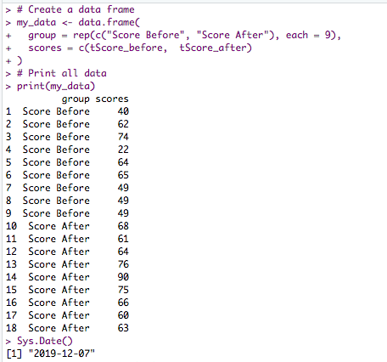
Figure 1 – Screenshot of creating and printing a new data frame.
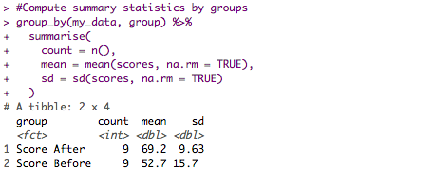
Figure 2 – Screenshot of summary statistics.
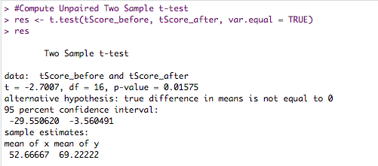
Figure 3 –Unpaired Two Sample t-test.

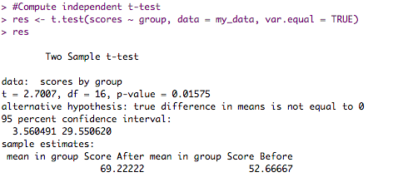
Figure 4 – Independent t-test.

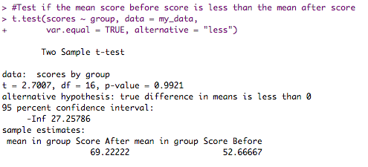
Figure 5 – Test if the mean before score is less than the mean after score, given the parameter alternative = “less”.

